20BCE1837

EX No. 5

Date: 7.9.2022

AIM: To execute JavaScript functions in an HTML website

Procedure:

1. Type the JavaScript functions and save in a .js file.

2. Link the .js file to the .html file.

3. Open the .html file inside a web browser.

Code:

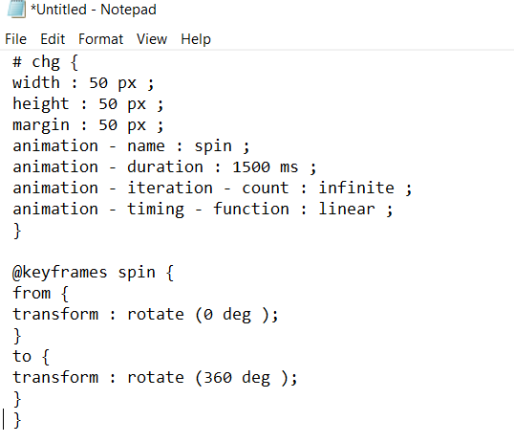

Index.html

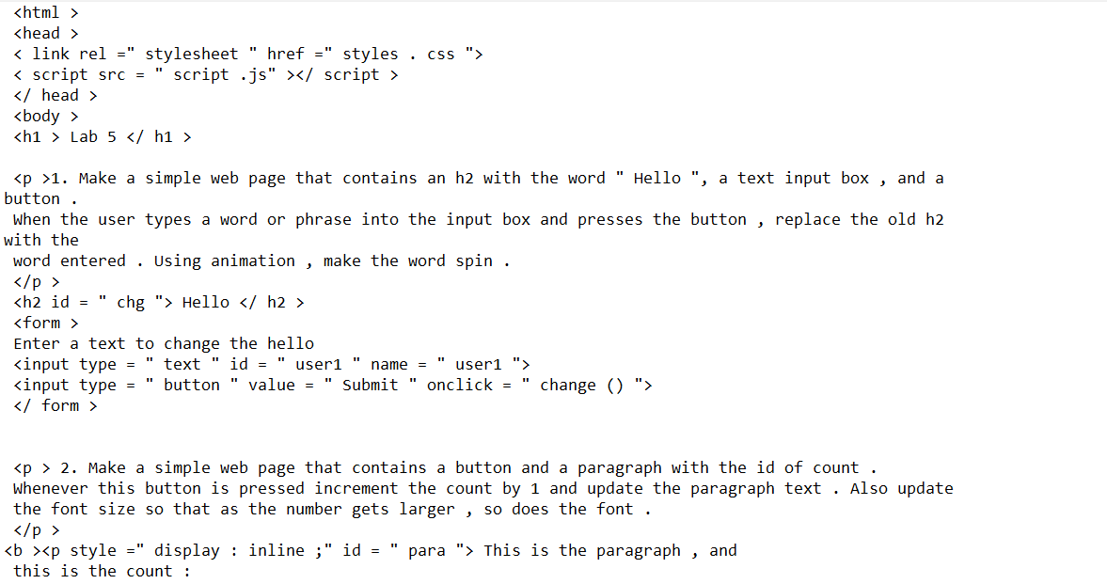

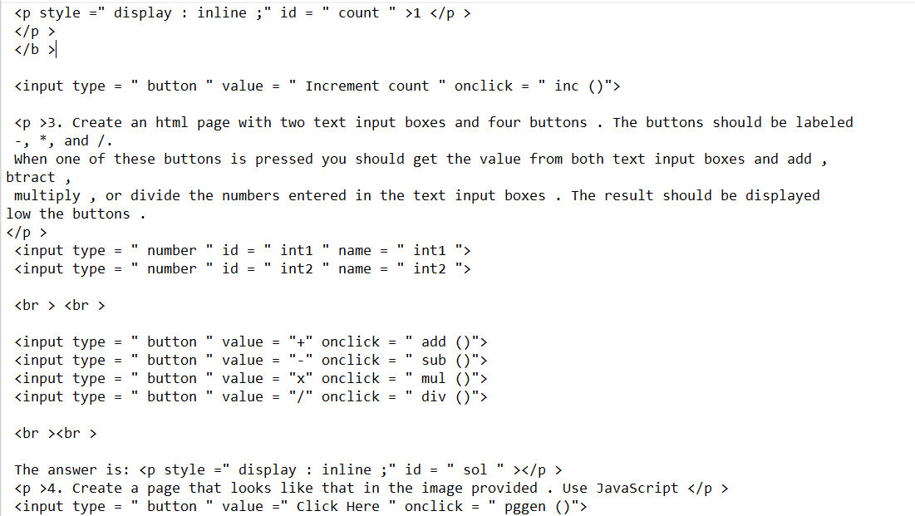

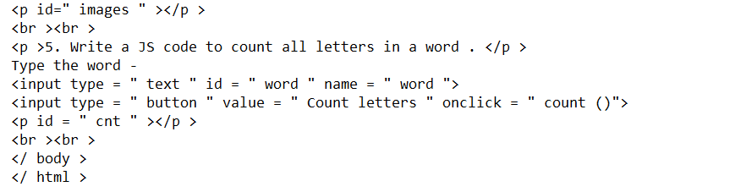

Script.js

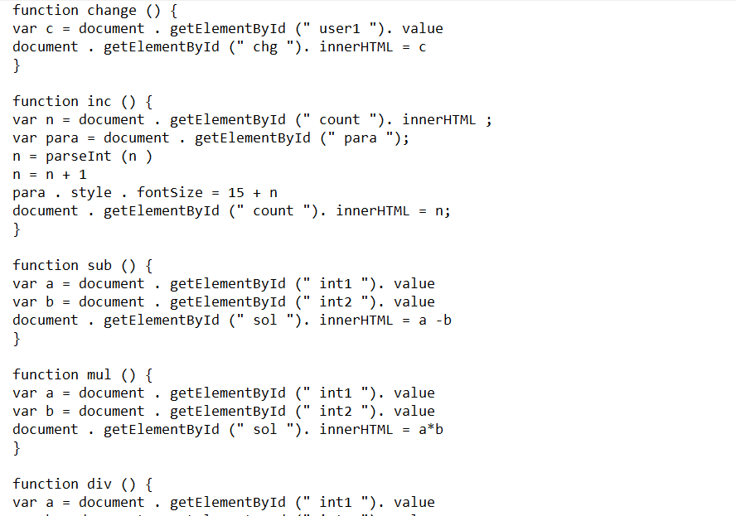

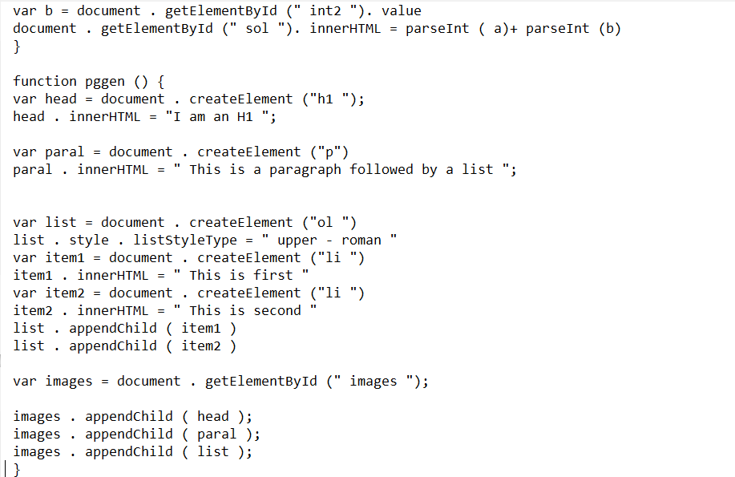

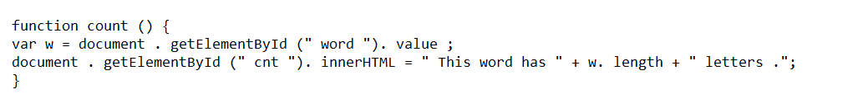

Output

1. Before:

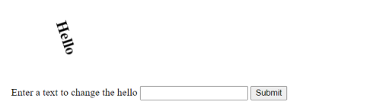

After:

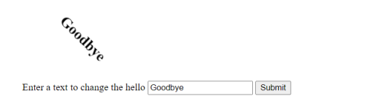

1. Before:

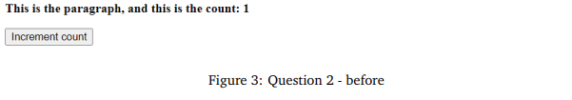

After:

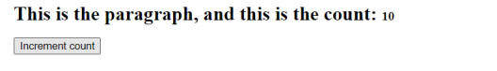

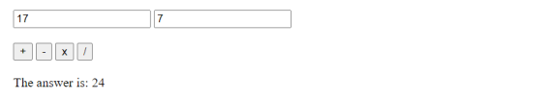

1. Before:



After:



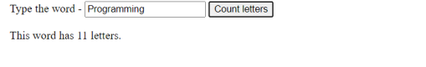

Results

The code was successfully executed and viewed in a browser.